

PROJECT ON

“Solar Inverter with Solar Battery Charging”

PHASE 2

Project report submitted for partial fulfillment of the requirement of the degree of Bachelor of Technology in Electrical & Electronics Engineering

Submitted by-

Abhranil Das, Roll no. 13

Ranjan Kumar, Roll no. 14

Sudipta Sarkar, Roll no. 15

May,2023

Under the guidance of, Hon’ble Professors,

Prof. Arijita Das

DEPARTMENT OF ELECTRICAL & ELECTRONICS ENGINEERING

INSTITUTE OF ENGINEERING & MANAGEMENT

SECTOR V, SALTLAKE ELECTRONIC COMPLEX,

KOLKATA-700091

# CERTIFICATE OF APPROVAL

This project report prepared by Abhranil Das, Ranjan Kumar, Sudipta Sarkar entitled “Solar Inverter with Solar Battery Charging” is hereby approved and certified as satisfactory to warrant its acceptance as a prerequisite to the Degree of B.Tech in Electrical & Electronics Engineering for which it has been submitted.

It is understood that by approval, the undersigned does not necessarily endorse or approve any statement made, opinion expressed or conclusion drawn therein, but approves the report only for the purpose for which it has been submitted.

Prof. Arijita Das

(Guide)

Examiner Examiner

Head of the Department

ACKNOWLEDGEMENT

We wish to express our profound gratitude and indebtedness to Prof. Arijita Das of the Department of Electrical & Electronics Engineering of Institute of Engineering & Management for introducing the present topic and for their inspiring guidance, constructive criticism and valuable suggestion throughout the project work.

We wish to convey our sincere thanks to all faculty members who have patiently extended all sorts of help in accomplishing this undertaking.

Date: 08.05.2023

Abhranil Das Ranjan Kumar Sudipta Sarkar

ABSTRACT

The world demand for electric energy is constantly increasing and conventional energy resources are diminishing and are at the edge of extinction, moreover, their prices are rising. For all these reasons, the need for alternative energy sources has become necessary and solar energy in particular has proved to be a very promising alternative because of its easy availability and pollution-free nature. Due to increasing efficiency, decreasing cost of solar panels, and improvement of the switching technology used for power conversion, we are interested in developing an inverter powered by PV panels that could supply stand-alone ac loads. Solar panels produce direct currents (dc) and to use them in home and industrial appliances, we should have ac output at certain required voltage levels and frequencies. Thus, the solar inverter converts the solar energy of the sun into useful electrical energy (dc to ac).

CONTENTS

1. Introduction

1. Literature Review

1. Components Required

1. Block Diagram

1. Working Procedure

1. Future Scope

1. Discussion

1. References

# INTRODUCTION

According to the National Renewable Energy Laboratory, the sunlight received by the earth in one hour is enough to meet the annual energy needs of all people worldwide. Solar energy is suitable for heating and electricity generation using photo voltaic cells. Solar power can restrict climate change as it produces no carbon emissions. Solar energy is the best alternative, which can replace fossil fuels like coal and gas for electricity generation which creates air, water, and land pollution.

An inverter is basically a converter that converts DC-AC power. The word "inverter" in the context of power electronics denotes a class of power conversion circuits that operates from a de voltage source or a de current source and converts it into ac voltage or current. It is a common inverter, but uses energy from the sun that is termed "solar energy". This kind of inverter helps in changing the DC- AC uses solar power.

Solid-state inverters have no moving parts and are used in a wide range of applications, from small switching power supplies in computers, to large electric utility high-voltage direct current applications that transport bulk power.

Solar inverters may be classified into three broad types:

Stand-alone inverters, are used in isolated systems where the inverter draws its DC energy from batteries charged by photovoltaic arrays. Many stand-alone inverters also incorporate integral battery chargers to replenish the battery from an AC source, when available. These do not interface in any way with the utility grid, and as such, are not required to have anti-islanding protection.

Grid tie inverters, which match phase with a utility-supplied sine wave. Gridtie inverters are designed to shut down automatically upon loss of utility supply, for safety reasons. They do not provide backup power during utility outages.

Battery backup inverters, are special inverters that are designed to draw energy from a battery, manage the battery charge via an onboard charger, and export excess energy to the utility grid. These inverters are capable of supplying AC energy to selected loads during a utility outage and are required to have anti-islanding protection.

Components:

Circuit Components for solar charger circuit:

* Solar panel – 12V
* LM317 voltage regulator
* DC battery
* Diode – 1n4007
* Capacitor – 0.1uF
* Schottky diode – 3A, 50V
* Resistors – 220, 680 ohms
* Pot – 2K
* Connecting wires

Circuit Components for inverter circuits:

* IC CD4047
* POT-100K
* Step-up Transformer (230v primary 9v-0-9v, 1.5A , secondary transformer connected in reverse)
* Capacitor – 2200uf(25V), 0.01uf, 0.1uf (600v) , 22uf(200V)
* 1N4007-Diode
* Resistors- 20K , 330, 820, 220, 220 ohms
* Led-1
* IRF540 MOSFET -2
* MOV RDN240

Components Description:

1. Solar panel:

Photo voltaic solar panels absorb sunlight as a source of energy to generate electricity. A photovoltaic (PV) module is a packaged, connect assembly of typically 6x10 photo voltaic solar cells. Photo voltaic modules constitute the photo voltaic array of a photovoltaic system that generates and supplies solar electricity in commercial and residential applications. Each module is rated by its DC output power under standard test conditions (STC), and typically ranges from 100 to 365 Watts (W) The efficiency of a module determines the area of a module given the same rated output an 8% efficient 230 W module will have twice the area of a 16% efficient 230 W module. There are a few commercially available solar modules that exceed efficiency of 22% and reportedly also exceeding 24%. A single solar module can produce only a limited amount of power; most installations contain multiple modules. A photo voltaic system typically includes an array of photo voltaic modules, an inverter, a battery pack for storage, interconnection wiring, and optionally a solar tracking mechanism. The most common application of solar panels is solar water heating systems. The price of solar power has continued to fall so that in many countries it is cheaper than ordinary fossil fuel electricity from the grid.

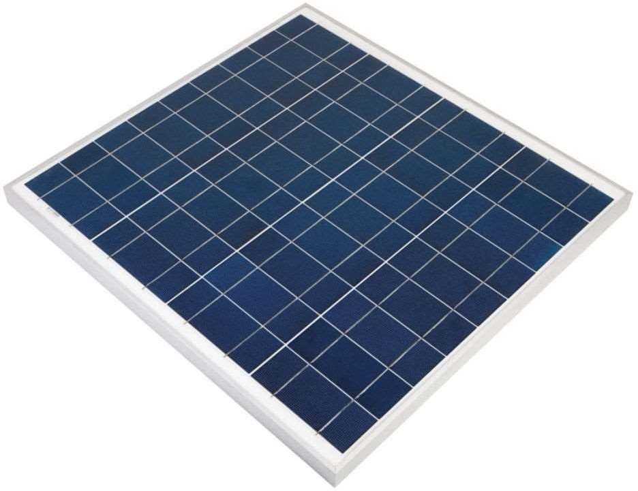

1. A Rechargeable Battery:

A rechargeable battery, storage battery, secondary cell, or accumulator is a type of electrical battery that can be charged, discharged into a load, and recharged many times, as opposed to a disposable or primary battery, which is supplied fully charged and discarded after use. It is composed of one or more electrochemical cells. The term "accumulator" is used as it accumulates and stores energy through a reversible electrochemical reaction. Rechargeable batteries are produced in many different shapes and sizes, ranging from button cells to megawatt systems connected to stabilize an electrical distribution network. Several different combinations of electrode

materials and anelectrolyteste are used, including lead-acid, nickel-cadmium, nickel-metal hydride, lithium-ion, and lithium-ion polymer.

During charging, the positive active material is oxidized, producing electrons, and the negative material is reduced. consuming electrons. These electrons constitute the current flow in the external circuit. The electrolyte may serve as a simple buffer for internal ion flow between the electrodes, as in lithium-ion and nickel-cadmium cells, or it may be an active participant in the electrochemical reaction, as in lead-acid cells. The energy used to charge rechargeable batteries usually comes from a battery charger using AC mains electricity, although some are equipped to use a vehicle's 12-volt DC power outlet. The voltage of the source must be higher than that of the battery to force current to flow into it, but not too much higher or the battery may be damaged.

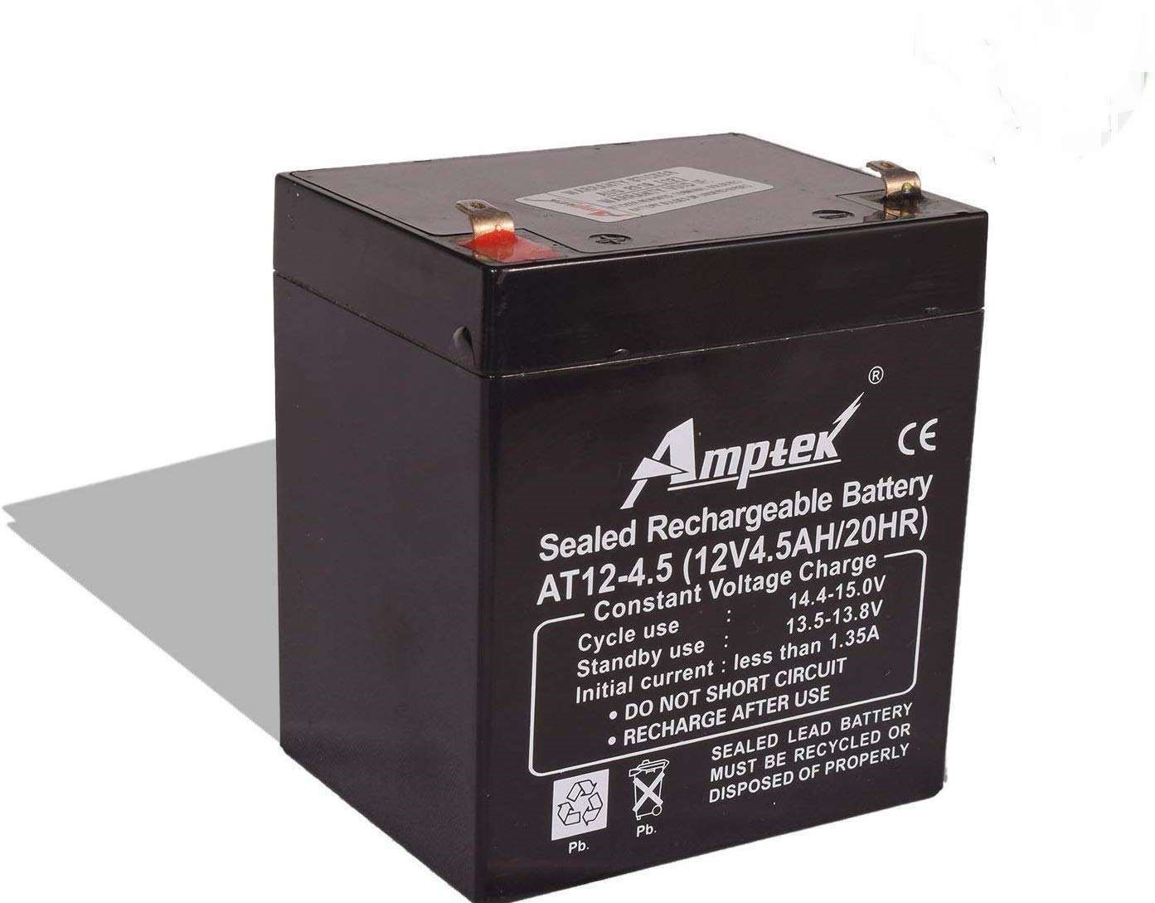

1. LM317 Voltage Controller:

It is a type of positive-linear-voltage regulator used for voltage regulation, which is invented by Robert C. Dobkin and Robert J. Widlar while they worked at the National Semiconductor in 1970. It is a three-terminal-adjustable-voltage regulator and is easy to use because to set the output voltage it requires only two external resistors in the LM317 voltage regulator circuit. It is majorly used for local and on-card regulation. If we connect a fixed resistor between the output and adjustment of the LM317 regulator, then the LM317 circuit can be used as a precision current regulator.

It can give an output voltage range from 1.25 V to 37 V with more than a 1.5A current rating. The final output from the regulator is given to 12/4.5Ah SLA Battery, this Battery provides DC bias to the inverter circuit. Regulator LM317 output voltage Vout can be obtained as

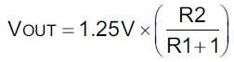

R2 => R2+VR1 for given inverter circuit.

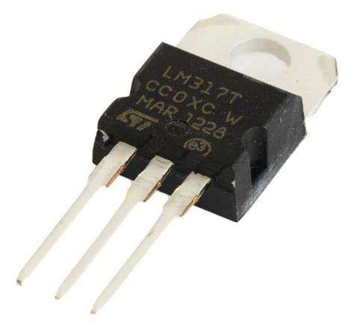

1. IC CD4047:

CD4047 is also a multivibrator IC. It can operate in two modes. A capacitor is connected externally between pins 1 and 3 to determine the pulse width of the output signal in the monostable mode and the output frequency is determined in astable mode by connecting a resistor between pins 2 and 3. A reset input is provided to reset the output of Q to 0 and the other output will become 1. This IC works in low power and available in 14 pin Dual in line package. It provides full Oscillation output F at Pin 13, 1/2 of oscillation at Pin 10 as Q and Pin 11 as Q’. each output pin gives 50% duty cycle.

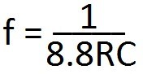

Here R => R4+VR2 and C=> C3. by using this formula we can obtain frequency output at pin 13. For pin 10 and 11 the formula changes as 𝑓 = 1/4.4𝑅𝐶.

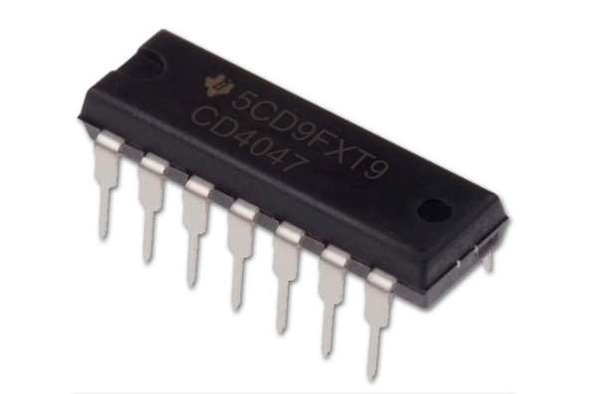

1. 1N4007-Diode:

A diode is a basic PN junction semiconductor device well-known in the microelectronics world. Because it is constructed with P and N-type materials. It acts as a one-way switch that allows the current to flow in one direction and halts in the other direction.

1N4007 belongs to the silicon family of1N400X series. It is a general-purpose rectifying diode that serves its purpose of converting alternating current signals(AC) to direct current signals (DC) in electronic products.

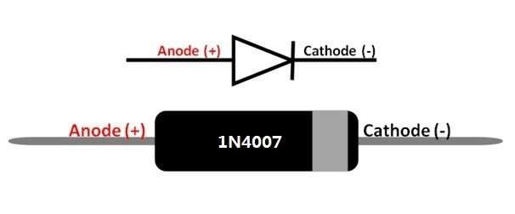

It has two terminals, i.e., Anode(positively charged) and Cathode (negatively charged). The diode has two states based on the connection of anode and cathode.

For the current to flow from anode to cathode, the anode should be connected to a higher potential than the cathode(forward biasing). The current which flows from anode to a cathode terminal is known as a forward current. Reverse biasing will restrict the flow of current and can damage the device if voltage applied is greater than reverse breakdown voltage. During reverse biasing a leakage current flows through a diode which is negligible compared to forward current.

6. IRF540 MOSFET:

An advanced HEXFET power MOSFET like IRF540N is from

International Rectifier that uses very complex processing methods to attain very low on-resistance for each ‘Si’ area.

The pin configuration of IRF540N MOSFET includes the following. This MOSFET IC is available with three pins where each pin & its purpose is discussed below. The IRF540N MOSFET symbol and pin configuration diagram is shown below.

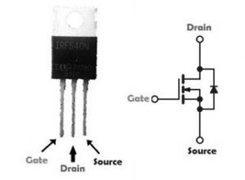

* Pin1 (Source): Current supplies out throughout Source terminal.
* Pin2 (Gate): This pin controls the MOSFET biasing.
* Pin3 (Drain): Current supplies throughout Drain terminal.

Block Diagram:

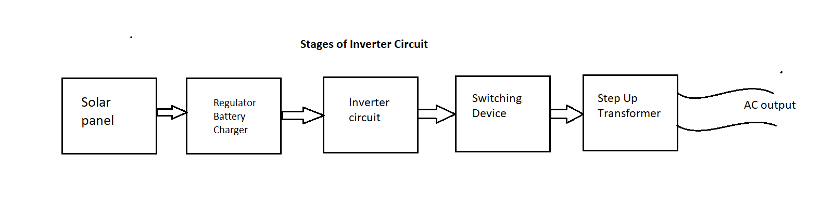

Circuit Diagram:

Solar Charger Circuit:

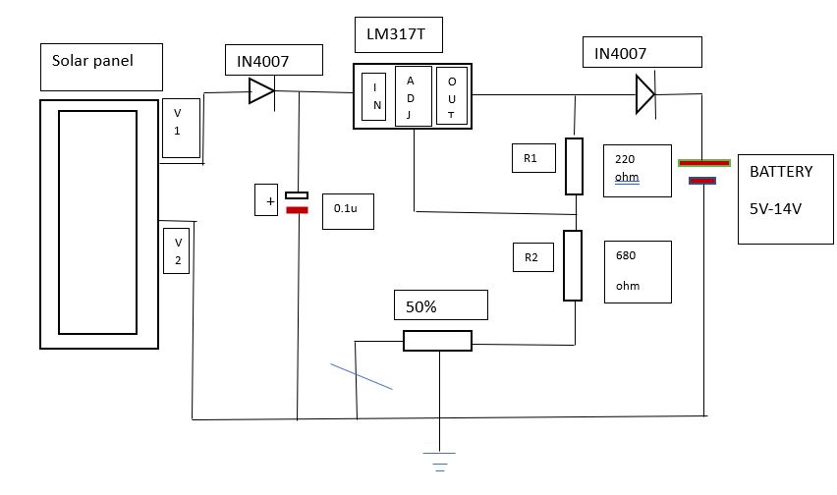

Solar Inverter Circuit:

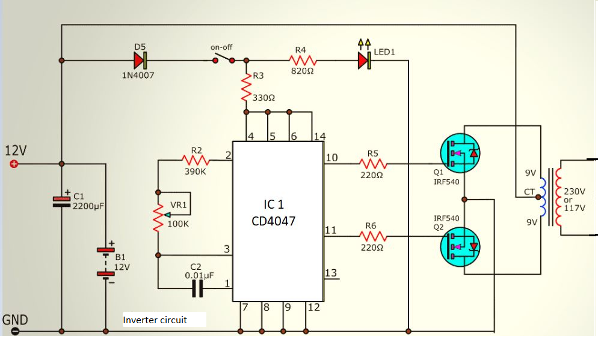

Actual Circuit:

Charger circuit:

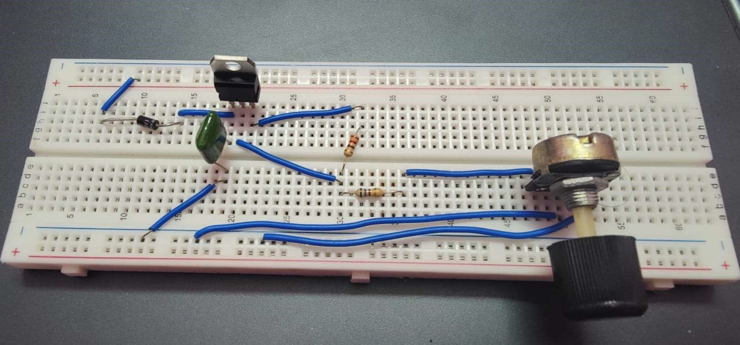

Inverter circuit:

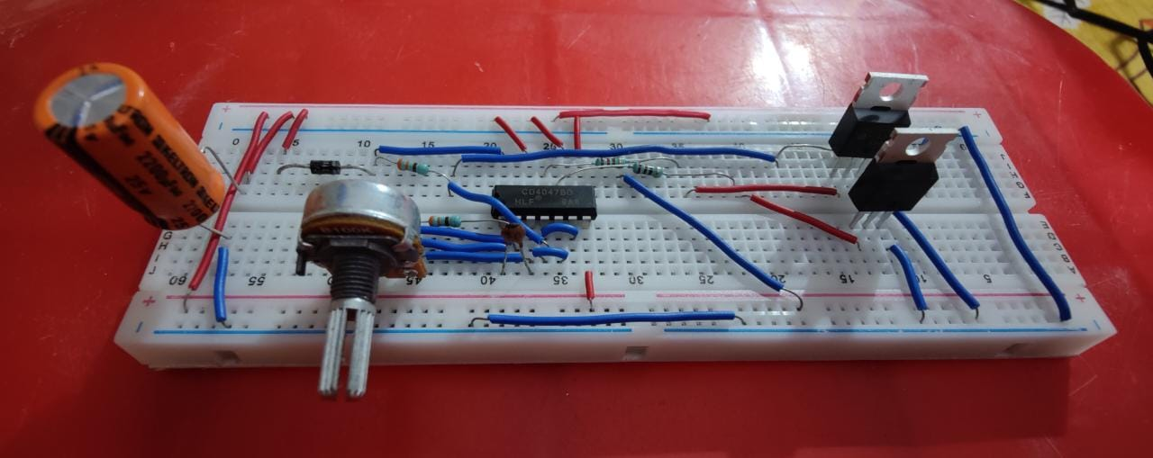

Working Procedure:

In this circuit 12 Volt / 20 Watts Solar panel used to get input bias, It gives peak 12 volt at 1600 mA when exposed to the open Sun.

## Regulator / Battery Charger

The LM317 adjustable three-terminal Positive voltage Regulator used here and can give an output voltage range from 1.25 V to 37 V with more than 1.5A current rating. The final output from the regulator is given to 12/4.5Ah SLA Battery, this Battery provides DC bias to the inverter circuit. Regulator LM317 output voltage Vout can be obtained as



R2 => R2+VR1 for the given inverter circuit.

## Inverter Circuit using IC CD4047 (Switching Pulse Oscillator)

Monostable / Astable multivibrator IC CD4047 used here to produce switching pulse, This IC works in low power and available in 14 pin Dual in line package.

It provides full Oscillation output F at Pin 13, 1/2 of oscillation at Pin 10 as Q and Pin 11 as Q’. each output pin gives 50% duty cycle.



Here R => R4+VR2 and C=> C3. by using this formula we can obtain frequency output at pin 13. For pin 10 and 11 the formula changes as

𝑓 = 1/4.4𝑅𝐶.

## MosFET drivers

IRF540 N Channel power mosfet from vishay siliconix used as a switching drivers for this inverter circuit. It gives fast switching, and have high operating temperature characteristics (175ºC).

## Output Stage

The main part of the solar inverter is the output stage, here transformer X1 is used in reverse with specifications as 230V primary, 9V-0-9V / 1.5A secondary winding center tapped transformer. MOV (Metal Oxide Varistor) protects electronic devices connected at the output.

The solar panel output voltage is directly fed into the LM317 positive Regulator circuit and it is adjusted to give 12-volt output and the Battery is connected to this bias through (3A, 50V) Schottky diode.

The CD4047 IC is connected and configured as Astable multivibrator, When we turn ON SPST switch this circuit starts oscillating. Output Q and Q’ are directly fed into switching power MOSFET IRF540 & drive X1 transformer secondary winding, here the current flow occurs particular duration and not for a particular duration. So varying electromagnet induced and primary winding coil produce EMF, hence we get Alternating current output. Depending on the count of winding and switching frequency output Voltage/Frequency gets varied.

FUTURE SCOPE:

The whole world is facing the problem of global warming and the energy crisis, our project will help to reduce these problems by using solar energy to generate electricity. Solar energy is an infinite source of energy. The main motto of our project is to promote the use of renewable energy sources. This project is most useful in our life because in this project one time investment is fixed on a lifetime. In the future one-day nonrenewable energy will end then we will use to renewable energy. The solar inverter made by us is just a prototype for making future projects which incorporate advanced technologies like micro controlled solar tracking, charge control, etc. this is to show that solar inverters are very cheap and easy to install so that the energy demands are shifted using renewable sources of energy. There is more advancements pending in this field which will revolutionize the energy stream and solar energy will be playing the most important role of all.

Discussion:

From this paper It is observed that the hybrid inverter with solar battery charging provides an uninterrupted power supply during the power cuts. It is also economical as we are using solar power, which is free of cost. The solar power is also pollution free and eco-friendly in nature. A solar hybrid system stores your excess solar energy and can also provide back-up power during a blackout. As the inverter provides uninterrupted power supply, this project is applicable in the areas like hospitals, educational institutions etc. All the circuit topologies proposed in the present work is related to a single-phase inverter system. Thus, these topologies can be easily extended for the threephase system. The inverter used in this project is combined with both ac and solar power. This can be extended by combing solar with wind energy and other renewable sources.

References:

1. UG.Pragnesh B. Gohil,UG.Digvijay P. Jadav,"Solar Battery Charger"LJEDR. Volume 5,Issue2.
2. Craig Danton Nimit Mehta," power inverter".
3. Jim Doucet,Dan, Eggleston Jeremy Shaw, "De to Ac pure Sine Wave Inverter".NECAMSID.
4. Babarinde, O. O, Adeleke, B. S, "Design and Construction of 1kVA Inverter". International Journal of Emerging Engineering Research and Technology. Volume 2, Issue 3, June 2014, PP 201-212.
5. A. Tuladhar, H. Jin. T. Unger, and K. Mauch, "Parallel Operation of Single Phase Inverters with no Control Interconnections," Power Electronics Specialists Conference, PESC 98 Record, 29th Annual IEEE. Vol. 1, pp.

892-898. [3] The Authoritative Dictionary of IEEE Standards Terms,

Seventh Edition, IEEE Press, 2000, ISBN 0-7381-260